SOLUTION ARCHITECTURE

**IoT Based Safety Gadget for Child Safety Monitoring and Notification**

DESIGN:

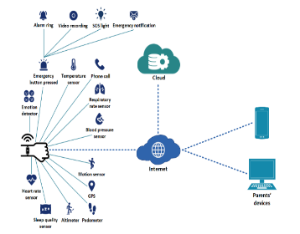

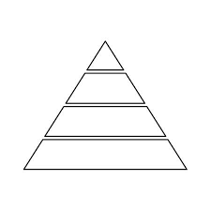

*DEVICE LIFETIME:*

**The device uses solar charging unit is proposed to overcome the limitation of small battery life so that the device will be always charged up. When there isn’t sufficient solar energy battery back up is also available. This can be used for over long period without any limitations. The device can be used all the time unless any physical damage takes place.**

***PURPOSE OF CHILD MONITORING DEVICES***

**It makes parents to easily monitor their children in real time just like staying beside them as well as focusing on their own career without any manual intervention. Basically, children cannot complain about abusements which they face in their daily life to their parents**.

TEAM ID: PNT2022TMID37952

TEAM BATCH NO: B7-1A3E

TEAM MENTOR: R. PADMAVATHY

TEAM LEADER: S. MADHUVANTHHI

TEAM MEMBERS: P. GLANY ROSE

V. POOJA

R. SANGEETHA

**here**

***FUNCTION:***

**The device has IoT monitoring and a GSM module that allows the child to be monitored at all times. It also has numerous sensors that are connected to a CPU and are used to detect exact signals such as heart rate, temperature, and other dangers and alert the parents.**